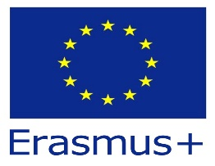


PROGRAMME OF THE TRANSNATIONAL ERASMUS+ MEETING
2024-1-FR01-KA210-SCH- 000254289

Day 1: 17 December 2024
- Ice-breaking activities
- Familiarizing of the participants: each partner will present their school/country/city and will give information on environmental issues they face
- Brainstorming to determine additional interesting activities which can be implemented during the mobilities

Day 2: 18 December 2024
- Project implementation workshop: discussing essential aspects of the project
- Continuing the discussion regarding project implementation

Day 3: 19 December 2024
- Demonstrative lessons held by participants to illustrate country-specific approaches to environmental issues
- Agreeing upon the final version of the project implementation plan

